UPWARD CAMERA POWER CABLE

- PARTS LIST:

QUANTITY: PART #: NOMENCLATURE: LENGTH:

2 PER CABLE (2 PER MACHINE) 17053- TERMINAL, SPADE N/A

1 PER CABLE (1 PER MACHINE) 17661- 12-PIN CONNECTOR FOR SONY N/A

1 PER CABLE (1 PER MACHINE) 19104- WIRE, YELLOW, 22 AWG 44”

1 PER CABLE (1 PER MACHINE) 19105- WIRE, BLUE, 22 AWG 44”

1 PER CABLE (1 PER MACHINE) 46776- SLEEVING, ¼” 42”

- 12 – PIN CONNECTOR ASSEMBLY:

- SOLDER THE 22 AWG BLUE WIRE TO PIN #1 ON THE CONNECTOR IN ACCORDANCE WITH DIAGRAM #1.

- SOLDER THE 22 AWG YELLOW WIRE TO PIN #2 ON THE CONNECTOR IN ACCORDANCE WITH DIAGRAM #1.

- BURN THE ENDS OF THE SLEEVING.

- INSERT THE WIRES INTO THE SLEEVING AND ASSEMBLE THE CONNECTOR.

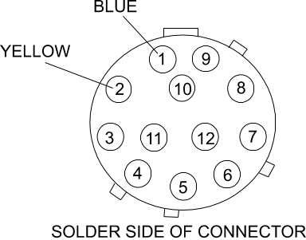
DIAGRAM #1

- OPPOSITE WIRE TERMINATIONS:

- STRIP ¼” OF INSULATION FROM THE OPPOSITE ENDS OF THE BLUE AND YELLOW WIRES.

- CRIMP A SPADE TERMINAL TO EACH WIRE.

